**ClearPath**

**System Design Document**

**Version <2.5.1>**

**3/18/2025**

# Document Control

## Distribution List

The following list of people will receive a copy of this document every time a new version of this document becomes available:

Teaching assistant: Rajagopal Sugumar

Customer: Dr. Masood Towhidnejad

Project team members:

Isaac Hewitt

Cannon Newbury

Michael Yun

Sadeed Khan

## Change Summary

The following table details changes made between versions of this document:

|  |  |  |  |
| --- | --- | --- | --- |
| **Version** | **Date** | **Modifier** | **Description** |
| 1.0 | 10/24/2024 | SK, CN | Initial version of SDD document |
| 1.1 | 11/21/204 | IH, CN | Updated SDD – software processes |
| 2.0 | 2/06/2025 | SK, CN | Fixing comments made to SDD and aligning it with the SRS (final version) |
| 2.1 | 2/20/2025 | CN | Changes to verbiage and charts |
| 2.2 | 2/27/2025 | CN | Major changes regarding shift in focus |
| 2.3 | 3/4/2025 | CN | Added Section for Justification of changes |
| 2.4 | 3/15/2025 | CN | Adjusting SDD to fit shift in focus |
| 2.5 | 3/18/2025 | CN, MY | Fixing diagrams, addressing comments |
| 2.5.1 | 3/18/2025 | MY | Ensure changes reflect shift to NOAA and ATC |

Table of Contents

Document Control 1

Distribution List 2

Change Summary 2

1. Introduction 3

1.1. Purpose and Scope 4

1.2. Project Executive Summary 4

1.2.1. System Overview 5

1.2.2. Design Constraints 6

1.2.3. Future Contingencies 6

1.3. Document Organization 7

1.4. Definitions, Acronyms, and Abbreviations 7

1.4.1. Acronyms 8

1.4.2. Abbreviations 9

2. System Architecture 10

2.1. System Hardware Architecture 11

2.2. System Software Architecture 12

2.3. Internal Communications Architecture 12

3. Human-Machine Interface 13

3.1. Inputs 13

3.1.1. Simulation Controls and Input Mechanisms 13

3.2. Outputs 13

3.2.1. Real-Time Data and Visual Displays 13

3.2.2. User Interface and Interaction 14

4. Detailed Design 14

4.1. Hardware Detailed Design 15

4.2. Software Detailed Design 15

4.3. Internal Communications Detailed Design 15

5. External Interfaces 16

5.1. Hardware Interface Architecture 17

5.2. Hardware Interface Detailed Design 17

5.3. Software Interface Architecture 17

5.4. Software Interface Detailed Design 17

6. System Integrity Controls 18

6.1. Internal Security 18

7. Justification 18

7.1. Integration of NOAA Weather Plugin and X-ATC Chatter into ClearPath 18

7.1.1. Introduction 18

7.2. ClearPath METAR Weather System (CMWS) Integration 18

7.2.1. Purpose and Functionality 18

7.2.2. Key Features: 18

7.2.3. Implementation in ClearPath 18

7.2.4. Impact on Simulation Fidelity 19

7.3. ClearPath ATC Communication System (CACS) Development 19

7.3.1. Purpose and Functionality 19

7.3.2. Key Features: 19

7.3.3. Implementation in ClearPath 19

7.3.4. Impact on Training and Research 19

7.4. Conclusion 20

# Introduction

## Purpose and Scope

The ClearPath project aims to enhance the realism of our XPlane-based flight simulation environment by implementing NOAA METAR weather, ATC chatter via ATC-Chatter, and live flight data for AI aircraft. Rather than developing new software, our objective is to integrate and configure existing plugins that leverage real-world data sources to create a highly immersive and accurate flight simulation experience. By carefully implementing and fine-tuning these plugins, we will ensure that users experience real-world aviation conditions within the constraints of our available simulation hardware.

This document outlines the system design and integration approach for achieving this goal. It details the selection, configuration, and testing of the chosen plugins to ensure smooth interoperability with XPlane. The ClearPath system is intended to serve as a research and training platform, helping users experience authentic flight operations and airspace conditions.

**Project Summary:**

The ClearPath system is designed to integrate existing simulation technologies to create a dynamic and realistic flight experience. The system will focus on the implementation of the following key components:

* NOAA METAR Weather: Integration of real-time METAR data from NOAA to provide dynamically updated weather conditions within XPlane, including visibility, wind patterns, and precipitation.
* ATC Chatter through ATC-Chatter: Implementation of ATC-Chatter to provide pre-recorded air traffic control communications, dynamically played based on the aircraft’s geographical location and phase of flight.
* Live Flight Data for AI Aircraft: Incorporation of real-world flight data from sources such as OpenSky Network and ADS-B.fi to populate AI aircraft in XPlane, ensuring that live traffic is accurately represented in the simulator.

This project does not involve developing new simulation logic or software from scratch. Instead, we will focus on the selection, configuration, and optimization of existing plugins to ensure seamless operation and realistic output. Our goal is to provide a fully integrated, high-fidelity training and research tool that mirrors real-world aviation operations.

## Project Executive Summary

The ClearPath project is focused on integrating existing plugins into XPlane to provide a realistic and data-driven flight simulation experience. Rather than developing custom software, our team is implementing well-established solutions to improve air traffic realism, meteorological accuracy, and ATC communication immersion. The system aims to enhance training and research by ensuring that the simulator environment closely mirrors real-world aviation operations.

To achieve this, ClearPath will integrate three primary components:

* Live Flight Data for AI Aircraft: Using real-time air traffic data from OpenSky Network and ADS-B.fi, the simulator will dynamically generate AI aircraft that match real-world movements.
* NOAA METAR Weather: The simulator will synchronize with real-time METAR weather data, ensuring accurate environmental conditions, including wind, temperature, and visibility.
* ATC Chatter through ATC-Chatter: The system will utilize region-specific recorded ATC communications to provide realistic background chatter and enhance the auditory immersion of flight operations.

The ClearPath system’s goal is to create a high-fidelity simulation environment without requiring extensive software development. Instead, the focus is on selecting, configuring, and integrating plugins that maximize realism while maintaining system performance.

### System Overview

The ClearPath system does not alter or modify XPlane’s base code. Instead, it leverages the simulator’s existing plugin architecture to integrate external data sources efficiently. Our implementation strategy prioritizes system stability, ensuring that live data updates do not introduce excessive lag or performance degradation.

ClearPath is designed for research and training applications where real-world accuracy is essential. By using real-time data streams and optimizing plugin configurations, the system will deliver an immersive, dynamic flight simulation environment that aligns with actual aviation operations.

Overall, the ClearPath system’s architecture supports a continuous flow of information between user inputs, live traffic data, and display outputs, providing an interactive and high-fidelity platform for aircraft training. Figure one shows ClearPath’s concept diagram. This shows the intricate inputs and outputs and what data is being passed through the program.

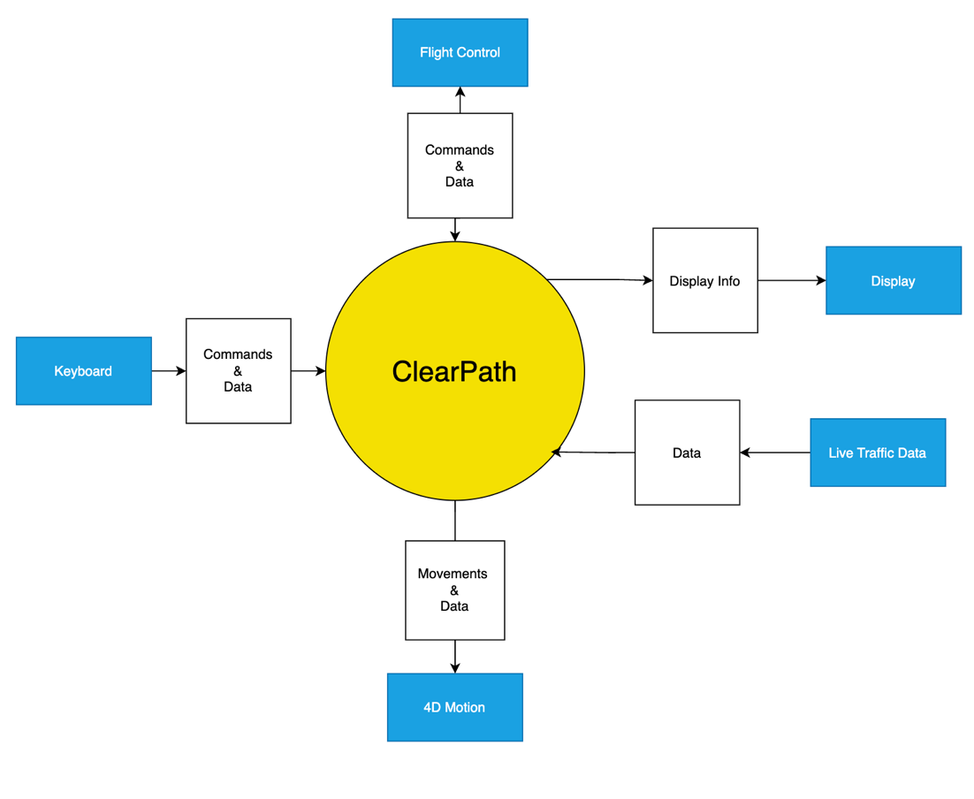

Figure 1. System context diagram

### Design Constraints

The ClearPath system must operate within the limitations of our existing hardware and XPlane’s software framework. The key constraints include:

* Hardware Performance: The system must run efficiently on available simulator hardware without compromising frame rates or overall performance.
* Software Compatibility: All implemented plugins must be compatible with XPlane 11 and must function cohesively without conflicting with core simulation processes.
* Real-Time Data Processing: The system must process and integrate live data feeds efficiently, ensuring that AI aircraft movements, weather conditions, and ATC chatter remain in sync.
* Network Dependence: The integration of live weather, traffic, and ATC chatter data relies on stable internet connectivity. Network disruptions could impact data updates and system performance.
* User Configuration Complexity: While ClearPath seeks to automate data integration as much as possible, some user adjustments may be required to fine-tune plugin settings for optimal performance and realism.

### Future Contingencies

To ensure the successful integration and operation of ClearPath, multiple contingencies have been considered to address potential challenges that may arise during implementation. Each aspect of the system—live AI traffic, NOAA METAR weather synchronization, and ATC-Chatter—relies on external data sources and XPlane’s plugin compatibility, requiring careful monitoring and troubleshooting.

* Live AI Traffic Implementation Challenges: One of the primary concerns is ensuring that real-time air traffic data from OpenSky Network and ADS-B.fi integrates smoothly into XPlane. In cases where data transmission errors occur, the system might need alternative API endpoints and backup data sources may be evaluated if integration issues persist.
* Weather Data Synchronization Challenges: Real-time weather data integration depends on NOAA METAR reports being reliably fetched and translated into XPlane’s environment. If issues arise with weather data accuracy or transmission delays, Xplane allows users to manually override weather settings if needed.
* ATC Audio Mapping Accuracy: The proper playback of ATC-Chatter recordings depends on accurate geographical mapping. If the system incorrectly assigns ATC recordings to an airspace sector, users may experience incorrect or irrelevant transmissions. To mitigate this, ATC regions and frequency data will be refined and tested rigorously before deployment.

## Document Organization

This document is organized into sections and subsections. The sections are Introduction, System Architecture, Human-Machine Interface, Detailed Design, External Interfaces, and System Integrity Controls. These sections have appropriate subsections with paragraph explanations and diagrams as needed. The Table of Contents may be used to properly navigate this document.

## Definitions, Acronyms, and Abbreviations

This section lists terms used in this document and their associated definitions.

**Table 1: Definitions in SDD**

|  |  |
| --- | --- |
| **Term** | **Definition** |
| **Game** | Refers to *XPlane 11*, the primary flight simulation software used for the ClearPath project. It provides a realistic aviation environment by simulating aircraft, weather conditions, and air traffic. |
| **ClearPath METAR Weather System (CMWS)** | A system that integrates real-world METAR-based weather data into *XPlane 11* to ensure dynamically updated atmospheric conditions such as wind patterns, temperature, cloud coverage, and turbulence. |
| **ClearPath ATC Communication System (CACS)** | A module within ClearPath designed to introduce realistic ATC communications by integrating an extensive database of pre-recorded ATC transmissions, played dynamically based on aircraft location and flight phase. |
| **Incursion** | A runway or taxiway incursion is any unauthorized presence of an aircraft, vehicle, or pedestrian in a protected area designated for aircraft operations, leading to potential conflicts or accidents. |
| **ADS-B (Automatic Dependent Surveillance–Broadcast)** | A surveillance technology that enables aircraft to broadcast their position, velocity, and other data to air traffic controllers and nearby aircraft in real-time. Used by ClearPath to populate AI aircraft within *XPlane 11*. |
| **OpenSky Network** | A global flight tracking network that collects real-time ADS-B data from aircraft and provides it through an API. ClearPath integrates this data to generate AI aircraft within the simulator. |
| **ATC Chatter Plugin** | A software add-on that plays pre-recorded ATC communications based on aircraft phase of flight and geographic location, enhancing realism in the simulation environment. |
| **NOAA METAR Weather Data** | Real-time meteorological data provided by the National Oceanic and Atmospheric Administration (NOAA), used by ClearPath to simulate accurate, real-world weather conditions. |
| **Simulation Controls** | A set of user inputs including yoke, throttle, pedal, and keyboard commands that allow users to interact with the ClearPath simulation system. |
| **Force Dynamics 401CR** | A 4D motion platform that physically moves in response to in-game aircraft behavior, providing realistic movement feedback to the pilot in the ClearPath simulation setup. |
| **Emergency Stop (E-Stop)** | A hardware safety mechanism integrated into the ClearPath simulator, allowing users to immediately halt all system movements and outputs in case of emergency. |
| **Proximity Threshold** | A configurable parameter within ClearPath that determines the minimum distance for detecting potential runway and taxiway incursions. |
| **Event Log** | A system-generated record of all detected incursions, storing details such as aircraft ID, timestamp, speed, and location for review and analysis. |

### Acronyms

This section lists the acronyms used in this document and their associated definitions.

**Table 2: Acronyms in SDD**

|  |  |
| --- | --- |
| **Term** | **Definition** |
| **SDD** | System Design Document, a formal documentation outlining the system architecture, components, and integration processes for ClearPath. |
| **METAR** | Meteorological Aerodrome Report, a standardized format for reporting weather conditions at airports, used to feed real-time weather data into the simulation. |
| **ATC** | Air Traffic Control, responsible for guiding aircraft within controlled airspace and preventing incursions. |
| **ADS-B** | Automatic Dependent Surveillance–Broadcast, a system that provides aircraft tracking data used by ClearPath for real-time AI traffic integration. |
| **NOAA** | National Oceanic and Atmospheric Administration, the U.S. agency that provides meteorological and climate data, including METAR reports used in the simulation. |
| **API** | Application Programming Interface, a set of protocols that allow software components to communicate. ClearPath utilizes APIs such as OpenSky Network and NOAA METAR feeds. |
| **HMI** | Human-Machine Interface, the user-facing component of the ClearPath system that facilitates interaction between users and the simulator. |
| **GUI** | Graphical User Interface, the on-screen interface that displays simulation controls, alerts, and live traffic data within the ClearPath system. |
| **ADS-B.fi** | An open-source ADS-B flight tracking service that provides real-time aircraft positioning data, integrated into ClearPath to simulate live AI traffic. |
| **4D Motion System** | A platform capable of simulating motion in four dimensions (yaw, pitch, roll, and heave) to replicate aircraft behavior within the simulator. |
| **FPS** | Frames Per Second, a measure of how smoothly the simulation renders graphics. A higher FPS ensures realistic aircraft movements and weather rendering. |
| **BIOS** | Basic Input/Output System, the firmware that manages system hardware initialization before loading the operating system. Required for booting up the ClearPath simulator. |
| **HDMI** | High-Definition Multimedia Interface, a digital video and audio interface used to connect the ClearPath display system. |

### Abbreviations

This section lists the abbreviations used in this document and their associated definitions.

**Table 3: Abbreviations in SDD**

|  |  |
| --- | --- |
| **Term** | **Definition** |
| **AI** | Artificial Intelligence, used in ClearPath to generate and control virtual aircraft based on real-world flight data. |
| **USB** | Universal Serial Bus, the interface used to connect simulation input devices such as the yoke, throttle, and pedals to the ClearPath system. |
| **BIOS** | Basic Input/Output System, responsible for initializing hardware components during system startup. |
| **WIP** | Work In Progress, indicating that a particular software feature or integration is still under development. |
| **CPU** | Central Processing Unit, the primary processor that handles all computations within the ClearPath simulation system. |
| **RAM** | Random Access Memory, temporary storage that enables fast access to simulation data. A minimum of 16GB RAM is recommended for ClearPath. |
| **SSD** | Solid-State Drive, a high-speed storage device used to store and quickly load the *XPlane 11* simulator and associated plugins. |
| **E-Stop** | Emergency Stop, a safety mechanism used to immediately halt all simulation movements and interactions in the event of a malfunction. |
| **HMI** | Human-Machine Interface, the system that allows users to interact with the ClearPath simulator using various input devices. |
| **CMWS** | ClearPath METAR Weather System, the module responsible for integrating real-world weather conditions into the simulator. |
| **CACS** | ClearPath ATC Communication System, the module that introduces realistic air traffic control communications. |
| **ADS-B.fi** | A data source that provides real-time aircraft positions via ADS-B transmissions, used for AI aircraft integration in ClearPath. |

# System Architecture

## System Hardware Architecture

The system hardware architecture includes a collection of hardware components that enable immersive training experiences by closely replicating real-world cockpit interactions. The architecture consists of the following key components:

* 4D Motion Platform: This component provides the physical movement that simulates the aircraft’s position and orientation changes. It is responsible for creating motion feedback based on the pilot's interactions with the simulator controls and the simulated aircraft's behavior.
* Computer: Serves as the central processing unit of the incursion system, coordinating inputs from the user and the 4D motion platform and generating corresponding outputs. The computer calculates responses to user input in real-time, producing motion feedback and updating the display to reflect the current scenario.
* Display: Provides the visual interface for the incursion system, showing real-time simulations of the runway environment, aircraft status, and external surroundings. This display helps users remain immersed in the simulated environment by providing a realistic view of the cockpit perspective and external conditions.
* User Input Controls: The pilot interacts with the incursion system using various control inputs, which include:
* Yoke: Represents the primary flight control, used by the pilot to manage the aircraft’s pitch and roll.
* Throttle/Mix/Flaps/Gear Controls: Control the power, fuel mixture, flaps, and landing gear, respectively, allowing the pilot to adjust various flight parameters as needed.
* Pedals: Control the aircraft’s yaw, simulating rudder control for directional adjustments during ground operations.
* Emergency Stop (E-Stop): Two E-Stop buttons are integrated into the system for safety. One E-Stop is positioned near the 4D motion platform to halt motion immediately if necessary. A second E-Stop is connected to the user input control panel, allowing the pilot or instructor to stop all interactions and outputs instantly in the event of a malfunction or unsafe scenario.

The figure below provides an image of how the hardware interacts with the other physical components as well as interacts with the user.

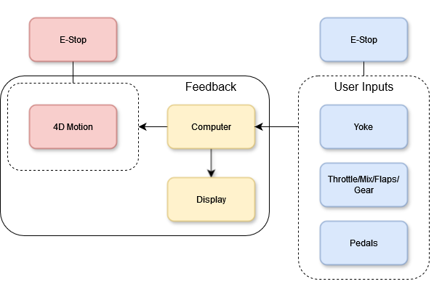

Figure 2. ClearPath Hardware Architecture

## System Software Architecture

Clear Path does not have any developed software as we are only handling the implementation and plugin integration between the multiple XPlane programs.

Figure 3. Software Architecture

## Internal Communications Architecture

Clear Paths internal software communication can be best found in Sections 4.3 & 5.4, where it is explained how the game is able to read the live traffic data, weather and ATC Chatter through the plugins.

# Human-Machine Interface

ClearPath System’s Human-Machine Interface (HMI) is designed to facilitate seamless interaction between users and the Force Dynamics 401CR simulation setup integrated with XPlane. This section outlines the specific input and output mechanisms for the user, ensuring that interactions are user-friendly and intuitive.

## Inputs

This subsection describes the user inputs for operating the ClearPath System, focusing on configuration, control, and safety.

### Simulation Controls and Input Mechanisms

This interface enables users to start, stop, and adjust simulation parameters and controls the initial setup and launch sequence required to activate the Force Dynamics 401CR and XPlane 11.

**Startup Sequence**:

1. **Turn on all power switches**: Ensure all necessary power switches on the Force Dynamics 401CR are switched on.
2. **Reset all emergency stops**: Confirm that all emergency-stop buttons are released.
3. **Boot into BIOS**: Start the system by accessing the BIOS.
4. **Press F1 to save changes in BIOS**: Press F1 to enter the BIOS, save any necessary changes, and then exit.
5. **Normal PC startup**: After exiting BIOS, the PC will boot up normally.
6. **Auto-launch Force Control Program**: The system will automatically open the Force Control program used to manage motion.
7. **Enable Motion**: Within the Force Control program, activate the motion by selecting “Enable Motion.”
8. **Press “Park Up”**: Prepare the simulator for operation by pressing “Park Up.”
9. **Launch XPlane 11**: Open and run XPlane 11 to begin the simulation

## Outputs

### Real-Time Data and Visual Displays

* Live Traffic Display: Aircraft rendered within the XPlane environment will be positioned based on real-time data from OpenSky Network and ADS-B.fi. These aircrafts will be displayed on in-game radar screens and navigation maps.
* Weather Visualization: NOAA METAR-sourced weather conditions, such as cloud cover, precipitation, and wind speed will be dynamically updated and reflected within the simulation environment. Changes in weather conditions will be represented at regular intervals to match actual aviation conditions.
* ATC Audio Playback: The ATC-Chatter plugin will output realistic air traffic control transmissions based on the aircraft’s geographical location. ATC chatter will play through the simulator’s audio system, providing background communication from various controllers (e.g., ground, tower, approach, center) appropriate to the aircraft’s location and phase of flight.

### User Interface and Interaction

* Navigation and Radar Screens: Users will have access to in-game radar displays, which will provide live traffic positioning, flight paths, and relevant aircraft details. This data will be synchronized with real-world flight tracking sources.
* Weather Information Panel: A user-accessible panel within XPlane will display real-time weather conditions as retrieved from NOAA METAR data, including updates to visibility, winds, and precipitation.
* Audio Management Controls: Users will have the ability to adjust ATC chatter volume and filter specific transmissions (e.g., tower vs. center communication) through an in-game settings menu, ensuring an optimal balance between simulation realism and user preference.

# Detailed Design

## Hardware Detailed Design

The ClearPath system operates on a 4D simulation platform with specific hardware components to create an immersive flight simulation experience. Below are the detailed specifications for each primary component:

* Power Input Requirements: The ClearPath simulator, including the yoke, throttle, mixture, RPM sliders, and monitors, requires a stable AC power supply. Each component is powered independently, and the power distribution system should be capable of supporting the entire setup without fluctuations.
* Signal Impedances and Logic States: The control inputs, such as the yoke and throttle, use standard signal levels compatible with the simulation software. The system components require updated drivers for the GPU and motion.
* Connector Specifications: The yoke, throttle, mixture, and RPM sliders are connected to the main computer, likely through USB connectors. Each of the three monitors is connected via HDMI or display cables to support high-definition video output.
* Memory and Storage Space Requirements: To achieve smooth performance at 120 frames per second (fps) on XPlane, the computer should be equipped with at least 16GB of RAM, though 32GB is recommended for optimal performance. Storage should include a minimum of a 512GB SSD to quickly access and load simulation data.
* Processor/Computing Platform Requirements: Running XPlane at 120 fps demands a high-performance processor. An Intel i7 (or equivalent) with multiple cores and a minimum clock speed of 3.5 GHz is recommended. A dedicated high-performance graphics card will help maintain frame rate across multiple displays.
* Hardware Items and Positioning: The ClearPath system includes a yoke, throttle, mixture, and RPM sliders as control inputs. Three monitors are positioned in an extended array around the user to provide a wide field of view and enhance immersion within the simulation.
* Cable Types and Lengths: HDMI or display cables connect the three monitors to the computer. USB cables connect the control inputs, such as the yoke and throttle, to the main system.
* User Interfaces: The main user interfaces include the yoke, throttle, mixture, and RPM sliders. These controls allow the user to interact with and adjust the aircraft’s flight dynamics, providing a hands-on simulation experience.

## Software Detailed Design

Clear Paths software design can be found in Sections 2.2 & 5.4.

## Internal Communications Detailed Design

The ClearPath system, built on a 4D simulation platform, consists of multiple components that require internal communication to function cohesively. This section outlines the expected design for internal communications to ensure reliable data exchange, command distribution, and input/output support.

* Number of Servers and Clients: The system includes one main computer that processes simulation data and manages inputs from various devices, such as the yoke, throttle, mixture, and RPM sliders. The three monitors connected to the computer function as display clients, receiving continuous output from the computer.
* Bus Timing Requirements and Control: To achieve the target performance in XPlane, the system requires high-speed data transfer between the computer and peripheral components.
* Data Format: The data exchanged between the components follows standard input/output protocols. Control input data from the yoke, throttle, mixture, and RPM sliders is transmitted in USB, processed by the main computer, and translated into real-time simulation adjustments. The output to the monitors is transmitted in HDMI video signal format to ensure high-definition visual rendering. We also expect the live traffic data to integrate into XPlane via an Application Program Interface.
* Data Flow: The yoke, throttle, mixture, and RPM sliders send input data to the computer, where it is processed and integrated into the simulation. The live traffic data will be integrated into the simulation as 2D and 3D objects. The computer then sends video output to the three monitors.

# External Interfaces

## Hardware Interface Architecture

The Force Dynamics 401CR is not being changed for the scope of this project. The Force Dynamics 401CR simulator responds to changes in position, pitch, yaw, and roll in real-time depending on the user's inputs using the yoke and control box.

## Hardware Interface Detailed Design

The hardware design and interface has not been expanded as of now and has been described in Section 2, “System Architecture” and Section 3, “Human-Machine Interface”.

## Software Interface Architecture

The software design interface is dependent on databases communicating with XPlane 11. These databases, OpenSky Network and adsb.fi, work on independent user submitted data from around the world. The goal is to get this data implemented into the game (XPlane 11) via a plugin, allowing real-time traffic to be seen in the game. (WIP)

## Software Interface Detailed Design

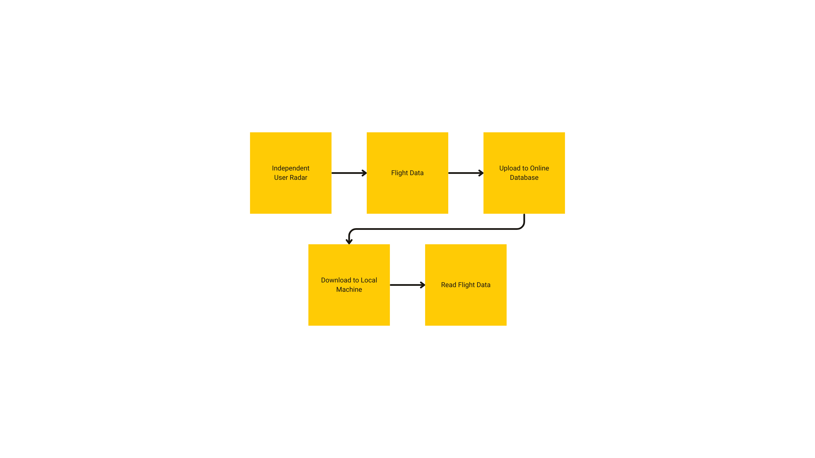

Figure 4. Detailed Software Communications (WIP)

OpenSky Network and ADSB-Fi contributors set up their own RADAR and use it to record flight data. Flight data is uploaded to an online database, either OpenSky Network or adsb.fi. This is then downloaded to our machine and then the machine reads this data. The next step is to get this data to display as planes in the game.

# System Integrity Controls

## Internal Security

The ClearPath system relies on security measures provided by the underlying operating system and XPlane itself. The simulator operates on a Windows-based system, which implements standard security protocols, including user account controls, firewall protection, and malware prevention. Additionally, XPlane includes built-in safeguards to prevent unauthorized modifications to its software and plugin architecture, ensuring that only verified and signed plugins are executed within the simulation environment.

# Justification

## Integration of NOAA Weather Plugin and X-ATC Chatter into ClearPath

### Introduction

The ClearPath project, originally focused on simulating runway incursions and integrating live traffic data into the X-Plane simulation environment, has expanded its scope to include the integration of two essential systems: **ClearPath METAR Weather System (CMWS)** and **ClearPath ATC Communication System (CACS)**. These additions aim to enhance simulation realism by incorporating real-time weather data and authentic air traffic control (ATC) communications. This document outlines the functionalities of these systems, their planned implementation within ClearPath, and the anticipated benefits for aviation training and research.

## ClearPath METAR Weather System (CMWS) Integration

### Purpose and Functionality

CMWS is designed to integrate real-world METAR-based weather data into the ClearPath simulation environment. By pulling meteorological reports from global METAR sources, CMWS will provide accurate atmospheric conditions, including wind patterns, turbulence, temperature variations, and cloud formations. This ensures that the simulated environment closely mirrors real-world weather scenarios.

### Key Features:

* **Real-Time METAR Data Processing:**Fetches and interprets METAR reports to generate accurate, real-time weather conditions.
* **Layered Wind and Turbulence Modeling:**Implements multiple layers of wind and turbulence to simulate real-world atmospheric effects.

### Implementation in ClearPath

Integrating CMWS within ClearPath will involve the following steps:

1. **Weather Data Processing System:**Configuring the backend system to fetch, interpret, and format real-time METAR data for use within the simulation.
2. **Integration with X-Plane Environment:**Ensuring the system seamlessly applies meteorological conditions to all simulated aircraft.

### Impact on Simulation Fidelity

CMWS will significantly enhance the realism of ClearPath simulations by:

* **Enhancing Pilot Training:**Users will need to respond to real-time weather conditions, improving their adaptability and situational awareness.
* **Improving Flight Planning Accuracy:**Real-world meteorological data will allow for precise and accurate flight planning exercises.
* **Expanding Research Applications**: Researchers can study aircraft and pilot responses to diverse weather conditions within a controlled, yet realistic, simulation environment.

## ClearPath ATC Communication System (CACS) Development

### Purpose and Functionality

CACS is designed to introduce realistic ATC communications into the ClearPath simulation environment. By integrating an extensive database of pre-recorded ATC transmissions and developing an intelligent playback system, CACS will replicate real-world ATC radio traffic, enhancing the training experience for users.

### Key Features:

* **Realistic ATC Audio System:**Plays ATC transmissions based on user location and flight phase.
* **Extensive Audio Database:**Developed from real-world ATC communications, categorized by geographic region and operational facility.
* **Context-Aware Playback System:**Ensures that ATC chatter corresponds to the appropriate region and phase of flight.

### Implementation in ClearPath

Integrating CACS within ClearPath will involve:

1. **Database Development:**Creating an extensive collection of region-specific ATC communications.
2. **Playback and Synchronization System:**Designing an algorithm that intelligently selects and plays ATC chatter based on user-defined and real-time parameters**.**
3. **User Customization Features:**Allowing users to modify the level of ATC interaction, ranging from passive background chatter to fully interactive ATC communications.

### Impact on Training and Research

Integrating CACS into ClearPath will provide several advantages:

* **Improved Pilot Communication Proficiency:**Pilots will develop better radio communication skills through exposure to realistic ATC interactions.
* **Increased Situational Awareness:**The inclusion of real-world ATC chatter provides context and enhances the user's perception of airspace activity.
* **Enhanced Training Immersion: The realistic auditory backdrop contributes to a more engaging and effective flight simulation experience.**

## Conclusion

The integration of **ClearPath METAR Weather System (CMWS)** and **ClearPath ATC Communication System (CACS)** represents a significant enhancement to the ClearPath project. These systems will provide a more immersive and authentic flight simulation experience, allowing users to interact with dynamic weather conditions and realistic ATC communications. By integrating these advanced features, ClearPath strengthens its position as a leading platform for aviation simulation, ensuring that pilots, researchers, and aviation professionals have access to state-of-the-art training tools.